Operation theatre complex – design considerations and guidelines

- Introduction
A note to the planners: Building layout design depends on the available space, service mix and planned volumes. Hence, providing a prescribed layout design for an eye hospital is not feasible. Instead, this architecture guide focuses on preferred practices and considerations to design an eye hospital. To make it practical, detailing is provided at a unit level. It is hoped that the planners will find this approach useful for the discussions to design the layout. To help with this, three sets of resources are included in this section -
- High-level layouts (PDFs) - as models to develop a better understanding of the flows, set-up, adjacencies, etc.
- Layouts at the unit level (PDFs) of consultation rooms, refraction lanes, investigation areas, etc.
- Detailed checklists –The checklists in the MS-EXCEl version are designed as tools for the planners to play with. The versions can be downloaded to work out the requirements (space, flows, electrical and waterline layouts, IT networks, etc.).
In the design of an operating theatre complex (OT), it is crucial to ensure the following:
- A safe and controlled environment for patients undergoing surgical procedures under local/general anaesthesia.
- Adequate space for perioperative care activities, including post-procedure recovery, particularly for patients who have received general anaesthesia.
- Efficient workflow and surgical throughput.
- Maintaining sterility where needed and in the flow of sterile supplies.

- Planning for an operation theatre complex:
Construction of an operating theatre complex requires substantial space and a significant financial investment. The actual area required for operating rooms also depends on other essential support areas, such as sterilisation, a sterile supplies room, dress change rooms, patient preparation, and recovery areas. Such support areas are common to multiple operating rooms. Thus, it is prudent to provide the required space in the same area if additional operating rooms are envisaged in the future – this could be either to handle the increased surgical volume or add newer surgical services. Building new operating rooms elsewhere would mean needing extra support spaces, increasing costs and reducing efficiency and space use. To facilitate this, the design must allow for adjoining spaces to be seamlessly integrated into the existing OT complex.

Cataracts and some sub-speciality surgeries now require only a short stay after surgery. Hence, the inclusion of the ambulatory ward as an extension to the OT complex enables efficient workflow and better patient care management, including pre-op checks and brief post-op recovery. The number of beds can be planned according to the daily surgical volumes and the patient turnaround time. In recent years, a significant number of patients undergoing eye surgeries also present with systemic conditions and may sometimes develop complications. Planning a mini-ICU area equipped with lifesaving equipment and medicines close to OT and the wards would enable prompt intervention when required.
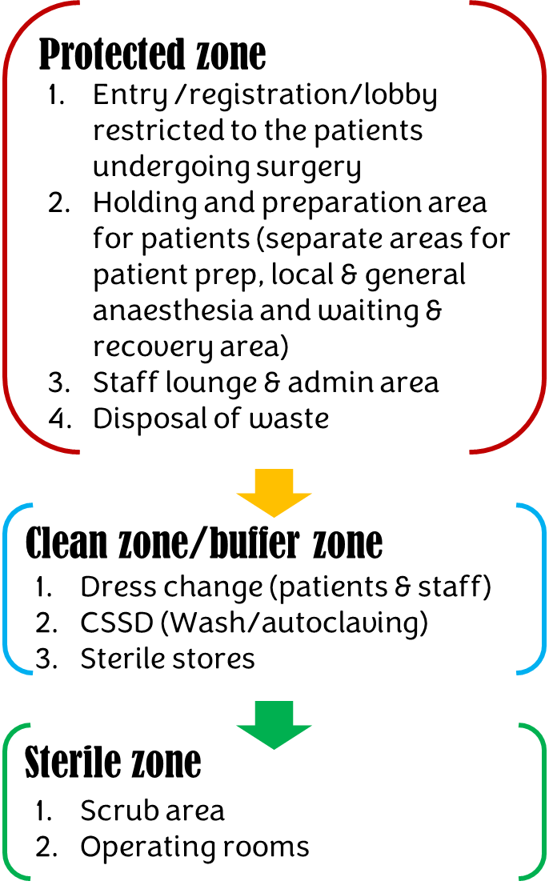
The operating theatre complex should be designed to function as a self-sufficient unit that facilitates patient flow and clinical processes carried out before, during, and after surgical procedures, to support high standards of patient care. The facility is typically divided into (i) a protected zone, (ii) a clean/buffer zone, and (iii) a sterile zone. The layout should facilitate (a) easy movement of patients, staff, and equipment, (b) efficient surgical workflows and optimal patient care by strategically designing the surgical suite's size, location, operating rooms, recovery beds, and support areas based on the estimated daily surgical load.

- Key considerations for the layout design of the OT complex:

- Location of the OT should help reduce contamination and support efficient workflow, taking into consideration space constraints. Ideally, it should be located where the patient/staff traffic is less, therefore avoiding the heavy traffic areas such as outpatient or administrative areas. If the OT complex is situated on the top floor, an additional layer of roofing should be considered to prevent rainwater seepage. Unlike normal ceilings, the ceilings within the OT complex tend to have a lot of equipment and air conditioning fixed to them, which, if not done well, could weaken the structure, leading to leaks. Thus, it is essential to use quality materials and skilled workmanship in constructing the OT complex, especially the ceilings. It is also advisable to avoid toilets right above the operating rooms. Any shortcomings in the quality of construction and materials tend to show up only after a few years. Repairing operating rooms at that time will be a nightmare, and it may (most likely) require suspending surgery for extended periods of time.

The location planning should incorporate extended adjacencies such as:
  - Preparation and anaesthesia recovery area
  - Mini-ICU – to manage any medical emergencies that may arise in the operating room or the wards.
  - Ambulatory ward and inpatient wards

Resource 1:
The resources provided in this section would offer a conceptual framework that comprises an OT complex and beyond. While the actual design may vary, considerations for the critical components mapped with adjacencies in the model layouts can result in a better design that is operationally efficient without compromising on aseptic practices. The planners may either view online or download the layouts (PDFs)and use them as a reference. Some countries may have specific criteria with respect to layout design and flow. It is important that local regulations are factored into the design and balanced with the preferred practices while finalising the layouts.

- Layout framework for OT complex (inside view):
This conceptual framework illustrates different sections, flows and dependencies that influence OT layout design PDF
- OT complex and adjacencies for efficient workflow (extended):
Presenting an integrated layout that comprises an OT complex, daycare wards and ICU

  - OT complex with single operating room for a secondary eye hospital – PDF
  - OT complex with multiple operating rooms for a high-volume eye hospital providing comprehensive eye care services – PDF

- Patient types: If the hospital serves different patient groups, especially the pay and free, provision for segregated patient flows - entry/exit, registration, and holding areas, can be considered. The design should also incorporate the movement pathway of these patient groups from the ward to OT and back. Alternatively, the surgeries for pay and free can be scheduled at different times or days. This becomes a necessity (a) from a cultural perspective or (b) to ensure exclusivity of services provided to the paying patients, or (c) due to operational reasons such as availability of human resources.

- Staff amenities: Change rooms and toilets shall be provided for male and female personnel (nurses, doctors, and technicians) working within the operating unit. The change rooms shall have space for donning surgical attire.

Staff change rooms can be situated to facilitate unidirectional movement so that personnel entering the change rooms from outside can change and move directly into the sterile zone (scrub area/operating rooms).

- Single corridor vs. twin corridor: Layout design plays a critical role in determining how sterile consumables and supplies are transferred from the sterile supplies area to the operating room without compromising aseptic protocols. The “twin corridor” design includes a dedicated corridor for the transfer of clean and sterile supplies from the storage area to the operating rooms. Similarly, unclean/used supplies and biomedical waste can be brought to CSSD either through a separate passage or the regular passage used by patients.

If the space is not a constraint, it is highly recommended to choose the "twin corridor” model. Since this has space implications, it is important to decide at the design stage itself.

- Design considerations for operating room set-up:
The layout design of large tertiary eye hospitals may include separate operating rooms to manage the daily volumes of sub-speciality surgeries thereby reducing the wait times and scheduling challenges. The key difference between these rooms will be the equipment used. In smaller eye hospitals, the same operating rooms may be utilised to perform cataract and other sub-speciality surgeries with proper scheduling.

One of the goals of the layout design of an operating theatre complex is to allow an efficient workflow process in addition to keeping a sterile ecosystem. The layout design plays a key role in achieving this – key concepts are listed below -
- Modular design of operating rooms: In recent years, the concept of modular operating rooms has become popular and widely adopted. The key goal is to achieve safe, infection-free, clean and sterile conditions maintained in each operating room. Since modular OTs are built by workers specialising in this, it is more likely to meet the laid-down standards. This will include the following:
- Separate air handling units (AHU) with HEPA filters and air-conditioning units, along with monitoring and control devices for each operating room. This helps in many ways – for instance, surgical sessions can continue uninterrupted even if one of the operating rooms becomes dysfunctional. This model can also help with better infection control mechanisms, which are paramount to the effective functioning of the OT.
- Walls and floors
- Floors: Smooth but anti-slippery, stain-resistant flooring materials, such as Epoxy or vinyl flooring, can be considered in the operating rooms and the corridors in sterile zones.
- Walls:
  - Seamless and impermeable finish to be considered (IG sir - can we mention some examples on the type of materials that can be considered for the walls) in the following areas
- Operating rooms
- Sterile corridors
- Autoclaving and instrument cleaning areas
- Block areas
  - Intersections of walls should be curved to disallow dust particles from settling in and also to help be better cleaning.
  - Ceilings: which are smooth and impermeable (specific examples)
  - Colours: Light colours can be considered for the walls, ceilings and floors.
- Temperature & humidity: Temperature, humidity and air pressure levels should be maintained as per the recommended practices in the operating rooms. Window & split ACs are not recommended for the operating rooms since they are prone to having pockets of microbial growth.
- Positive pressure: The air pressure in the operating room should be maintained at a higher level than ambient air pressure. This will ensure that unfiltered air doesn’t enter the operating rooms.
- Cabling and power sockets: Operating rooms in eye hospitals are equipped with multiple equipment such as operating microscopes, phaco & vitrectomy machines, monitors, etc. It is highly recommended to plan for a ceiling-mount pendant to provide a power supply for the equipment. This will help avoid cables running on the floor and help with the safety of the patients and staff. The pendant should be fixed at a level to accommodate several types of microscopes. For instance, microscopes used for vitreo-retina surgeries and cataract surgeries can vary.

To construct modular OTs, one may opt for a prefabricated set-up customised to the specific needs of a hospital or achieve the same by adopting the concept of sourcing the right construction materials. The choice to go with a particular model will be primarily based on the costs, local capabilities, and availability of supplies.
- Efficiency:
The capacity utilisation levels of the operating rooms can be enhanced with appropriate workflows when aided by the layout design. From the design perspective, the turnaround time between surgeries can be reduced significantly either by:
  - By adopting a twin table system (while the surgery is in progress on one table, another patient can be prepared on the other table) [or]
  - By creating a holding area just outside the operating room, where the patient is prepared and wheeled inside.
This must be finalised at the design stage since it has direct implications on the space and patient flow process. Some countries may have specific guidelines relating to this, which should be taken into consideration.
- Flow (patients, staff & supplies): Careful attention should be given while planning the workflows, especially the clean and dirty workflows. The layout design can include:
  - separate pass boxes set up to transfer clean supplies (from the storage area) and used supplies (from OT to the cleaning area)
  - sterile corridors connecting sterile storage areas with operating rooms if the hospital plans for more than one or two operating rooms. In this case, the used supplies can be taken out through the regular doorway which is used by staff and patients.

- Autoclaving area for sterile supplies: In an eye hospital, sterile supplies are used by both outpatient clinics, wards, as well as the operating rooms. Hence, it is helpful to provide access to sterile supplies for all groups without compromising the aseptic practices expected of the OT complex.

It is recommended to place the Autoclaving area & sterile supply storage area within the OT complex. If the available space is limited, it can be planned on another floor with a provision of direct & exclusive access to the operating suite for the passage of sterile and used supplies. This can be achieved either through separate chutes or lifts to transfer clean and used goods. The layout design can incorporate the following:

- Linen/instruments wash/preparation area provided with access to receiving the dirty linen and used instruments. This section may include the following:
- A separate room to segregate biomedical waste –
- Linen washing/preparation (for the linen used only in the OT) – this will include a washing machine and a dryer to wash and dry the linen used in the OT). This is separate from the laundry services to address the needs of the rest of the hospital.
- Instruments cleaning and packing – This area should include a wash area with water outlets and power sockets to use equipment such as ultrasound cleaners to clean the surgical instruments and a platform to dry and arrange the instrument packs for the autoclaving process.
- Autoclaving area can consist of separate sections for steam autoclaving and gas autoclaving that uses ethylene oxide (ETO) to sterilize tubings, suctions, etc. Plasma sterliser is another option that can be considered as an alternative since ETO is considered as carcinogenic.

Steam autoclaves: The currently available steam autoclaves can run both long and short cycles at varying temperatures. Short cycles at higher temperatures can be used to sterilize surgical instruments in between surgeries to allow the teams to perform high volume surgeries in a daily surgical session. The recommended practice is to opt for a horizontal double-door autoclave set-up allowing unidirectional flow. This can be achieved by physically segregating the area into two – (a) for loading the clean but unsterile packs from one end and (b) unloading the packs that completed the autoclave cycle from the other end of the autoclave which opens in the sterile storage area.

Depending on the volumes, space can be provided to accommodate an additional horizontal autoclave that can be used to sterilize instruments in between surgeries. This can also help to sterilize an instrument when dropped with no sterile duplicate available to perform surgery.

A few hospitals may opt to include Ethylene oxide sterilisation (ETO) to sterilize tubing and others that cannot be autoclaved. This may need to be in a well-aerated secluded area that limits exposure & impact of ETO on the staff managing the sterilization process.
Note: Short-cycle sterilisation is not suitable for processing cannulated, complex instruments, suction, and other tubing, textiles, paper, or liquids
- Storage area: this is an essential part of the OT complex to ensure the availability of sterile supplies for the efficient functioning of the OT. This includes storage areas for:
  - autoclaved supplies – bins and packs with linen, instruments, and others
  - equipment – in most eye hospitals, the same operating rooms will be used for all types of eye surgeries – cataract and advanced surgeries which may require a distinct set of equipment such as Boyles apparatus for general anaesthesia, vitrectomy machine, etc. which may not be used all the time. It may be helpful to store them in a designated storage area when not in use. Similarly, designated bays for resources such as stretchers/trolleys/wheelchairs can be supplied so that these do not obstruct the movement of patients as well as staff.

The OT complex layout can include provision of access lanes to pass the sterile supplies to operating rooms as well as to the OPD without disturbing the routine flow of patients and staff in the OT complex

Resource 2:
The twin corridor layout model that proves the flow of different entities (supplies, patients, and staff)
  - Three OR model PDF (Aravind – DGL)
  - Two OR model PNG (we need to get the PDF version of Kovilpati OR complex)
  - OT complex with multiple operating rooms to handle cataracts and other sub-speciality surgeries (AEH TVL)

Checklists:
These tools will help the planners (a) to make sure essential elements of the OT complex are incorporated and (b) assess the space requirements. Though the checklists are exhaustive, they cannot be considered a conclusive list since technology and requirements keep evolving. The planners should feel free to include added elements as deemed appropriate.

Checklist 1 | High-level considerations for OT layout design: High-level and detailed EXCEL; PDF
Checklist 2 | Assessing requirements in terms of specific areas, to perform procedures and furniture for each section of the OT. EXCEL; PDF
Checklist 3 | Determining the requirements for power supply for equipment, lighting, etc. and water supply EXCEL; PDF
Checklist 4 | Equipment used in the CSSD. Since wattage may vary, a table is provided to document the wattage EXCEL; PDF

- OT complex layout design: Preferred practices
- Natural lighting in the corridors, staff lounge, patient recovery area, CSSD and operating rooms is desirable. Air-tight windows can help achieve this.
- Scrub areas to have surgeon’s sinks fitted with elbow/knee-operated taps set up closer to the operating rooms.
- Doors to the operating rooms should have doors with sensors for automatic opening and closing, with a viewing window to communicate.
- Safety and security: Access control for the entry into the OT complex can be considered to eliminate unauthorised entry into the OT complex. As a general security policy, provisions can be provided to set up surveillance cameras at strategic points.
- Water used in the OT: It is recommended to use filtered water through the reverse osmosis (RO) process. This can prevent any culture growth affecting surgical outcomes. An in-house RO plant with provisions to supply the water to the operating theatre complex can be considered. It is recommended to opt for stainless drums to hold the water at various stages of the filtration process (normal water, RO filter, as well as ultra-filtration process). It is highly suggested to have a separate RO filtering mechanism for the drinking water supply to the staff and patients.
- Provisions should be given for fire/smoke detection and alarm systems and firefighting equipment (auto-sprinklers, fire extinguishers, etc.)
- Gas outlets for the supply of oxygen and others should be provided in the pre-operative area where high-risk patients are handled. A designated area (away from the patient care area) to store additional gas cylinders can be considered.
- A separate bay can be planned, preferably in the semi-sterile/restricted zone, to allow the staff to conduct preventive maintenance and undertake simple repairs that can be managed by the in-house staff trained in instrument maintenance.
- A mini store inside the OT complex to keep an inventory of sterile consumables (e.g., IOLs, surgical blades, etc.) can help avoid last-minute surprises and improve efficiency. This sub store can be set up between the dress change area and the operating rooms with easy access for the staff managing the patients in the sterile zone. The area for sub-stores can be compact in size to accommodate a week’s consumption of consumables and other surgical supplies.
- It is recommended to designate an area in the layout design to add additional operating rooms to meet future demand.

To add:
Photos of different sections of OT; detailed layout of an operating room

HEPA – High-Efficiency Particulate Air
NABH -revised guidelines 2018, https://www.nabh.co/Announcement/RevisedGuidelines_AirConditioning.pdf

